# CSSE3101 – ADVANCED WEB TECHNOLOGIES

# MERN STACK DEVELOPMENT

# Objective:

In this lab activity, you are going learn DELETE and UPDATE operations the document in the MongoDB database.

**PART 1- APPLICATION SETUP for DELETE Operation.**

In the client folder, Create ManageStudents.js component by doing the following:

1. Import the following:

import React, { useState, useEffect } from "react";

import Axios from "axios";

1. Create state variables using useState hook.

const [listOfStudents, setlistOfStudents] = useState([]);

const [countRecords, setcountRecords] = useState(0);

1. Create a useEffect hook to accept the response from the server.

useEffect(() => {

         Axios.get("http://localhost:3001/getAllStudents")

            .then((response) => {

                    setlistOfStudents(response.data.students);

                    setcountRecords(response.data.count);

                })

            .catch((err) => {

                    console.log(err);

            });

     }, []);

1. In the <tbody> use the map() function to iterate over the response and display the data.

 listOfStudents.map((s) => {

                            return (

                                <tr>

                                    <td>{s.studId}</td>

                                    <td>{s.studName}</td>

                                    <td>{s.dept}</td>

                                </tr>

                            )

                        }

                        )

Display the number of records.

 <div>

  <h3>Number of Records: {countRecords}</h3>

 </div>

1. Add the Update and Delete buttons in the table body section.

 listOfStudents.map((s) => {

                            return (

                                <tr>

                                    <td>{s.studId}</td>

                                    <td>{s.studName}</td>

                                    <td>{s.dept}</td>

                                    <td>

                                     <button

                                        type= 'button'

                                        className= 'btn btn-info'>

                                      Update

                                     </button>

                                     <button

                                        type= 'button'

                                        className='btn btn-warning'

                                        onClick={()=>deleteStudent(s._id)}>

                                       Delete

                                     </button>

                                  </td>

                                </tr>

                            )

                        }

                        )

1. Add the event handler for the Delete button, passing as parameter the student id.

<button

                           type= 'button'

                           className='btn btn-warning'

                           onClick={()=>deleteStudent(s._id)}>

                           Delete

                  </button>

1. Create the deleteStudent function that sends an Axios request to the server to delete the selected record.

 const deleteStudent = (async (id) => {

          Axios.delete(`http://localhost:3001/delete/${id}`)

         .then((response) =>{

             setlistOfStudents(listOfStudents.filter((val) => { return val._id !== id }));

             setcountRecords(response.data.count);

         });

    });

**PART 2- Express DELETE Route in index.js**

1. In your server folder, update the **index.js** to add a new Express DELETE route to delete the selected record.

app.delete('/delete/:id', async(req,res) =>{

const id = req.params.id;

await StudentModel.findByIdAndRemove(id).exec();

const count = await StudentModel.countDocuments({});

const msg = 'Item Deleted ';

res.send({msg,count});

});

**PART 3- APPLICATION SETUP for UPDATE Operation.**

1. Create a new Component UpdateStudent.js which renders the same user interface as StudentRegister. You may just save a copy of the StudentRegister component and do the necessary changes.

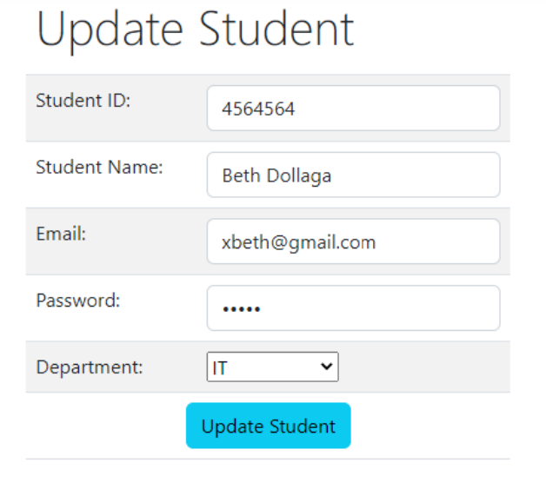

1. Update your App.js by adding a new Route for the update function.

<Route path="/update/:sid" element={<UpdateStudent />} />

1. In the ManageStudent.js component, add this import statement:

import {Link } from 'react-router-dom';

1. In the ManageStudent.js component, Use the Link component to convert the Update button into a link that will navigate to the update route.

<Link to={`/update/${s._id}`}>

       <button type= 'button' className= 'btn btn-info'>Update </button>

    </Link>

1. Edit UpdateStudent.js component to implement the update functionality by doing the following:
2. Add this import statement.

import { useParams } from 'react-router-dom';

1. After the state variables, declare a variable to store the parameter from the URL.

const [studId, setstudId] = useState("");

   const [studName, setstudName] = useState("");

   const [email, setemail] = useState("");

   const [password, setpassword] = useState("");

   const [dept, setDept] = useState("IT");

   const [responseMsg, setresponseMsg] = useState("");

**let { sid } = useParams();**

1. Create a useEffect hook which will be executed when the page renders or is loaded. The function will send a request to the server, adding in the URL the id of the selected record. When the server sends a response, assign the result to the setter methods of the state variables.

useEffect(() => {

        Axios.get(`http://localhost:3001/getStudentForUpdate/${sid}`)

            .then((response) => {

                setstudId(response.data.student.studId);

                setstudName(response.data.student.studName);

                setemail(response.data.student.email);

                setpassword(response.data.student.password);

                setDept(response.data.student.dept);

            })

            .catch((error) => { console.log(error); });

    }

        , []);

1. Add the attribute value in the form controls and assign the corresponding state variable. Do it for all the controls.

<input

type="text"

value={studId }

className="form-control"

onChange={(e) => setstudId(e.target.value)}

/>

1. In the server folder, update index.js and create a new Express GET route for the getStudent endpoint. At this point, the values are now displayed in the form controls.

app.get("/getStudentForUpdate/:id", async (req, res) => {

    try {

        const id = req.params.id;

        const student = await StudentModel.findById(id);

        const count = await StudentModel.countDocuments()

        res.send({student,count});

        } catch (err) {

        console.error(err);

        }

});

1. To save the updates/changes to the database the user will click the Update button. To implement this, do these steps:
   1. Edit UpdateStudent.js component, Add the event handler in the Update button to call the function updateStudent.

<tr> <td colSpan="2">

        <button className="btn btn-info" onClick={updateStudent}>

Update Student

</button>

       </td>

   </tr>

* 1. Edit UpdateStudent.js component,

const updateStudent = () => {

        Axios.put("http://localhost:3001/updateStudent", {

            studId: studId,

            studName: studName,

            email: email,

            password: password,

            dept: dept

        })

        .then((res) => {

            setresponseMsg(res.data.msg);

        })

      .catch((err) => { console.log(err);});

};

* 1. Display the value of the responseMsg state variable at the end of the table.

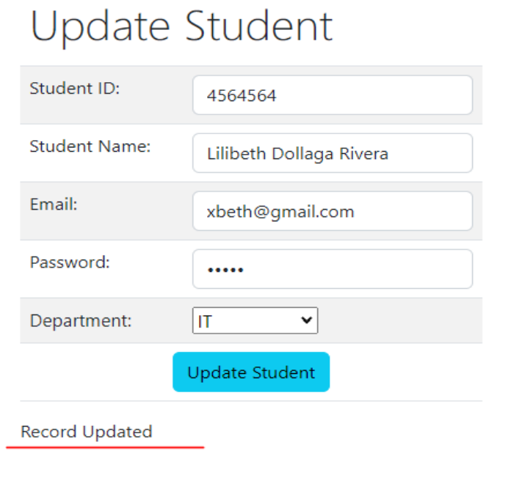

* 1. In the server folder, update index.js and add a new Express PUT route to handle the update endpoint.

//Express PUT route to update student documents in database

app.put("/updateStudent", async (req, res) => {

    const studId = req.body.studId;

    try {

        const studentUpdate = await StudentModel.findOne({ studId: studId });

        studentUpdate.studId = String(req.body.studId);

        studentUpdate.studName = String(req.body.studName);

        studentUpdate.email = String(req.body.email);

        studentUpdate.password = String(req.body.password);

        studentUpdate.dept = String(req.body.dept);

        await studentUpdate.save();

        res.send({ msg: "Record Updated successfully" })

    }

    catch (err) {

        res.send({ error: "Failed to update student" });

    }

});

Required Submission.

Once you complete the lab activity, you are required to upload the database model file student.js, server folder and src folder of the client app.